Day 21 — Spark Catalog

Build.sbt
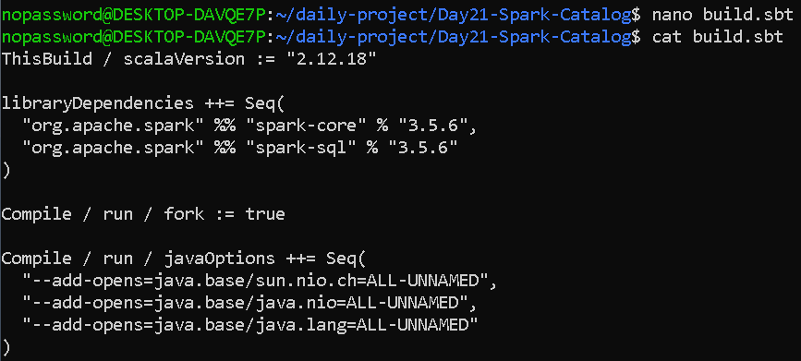

Create the Scala program
nano SparkCatalogPractice.scala
import org.apache.spark.sql.SparkSession

object SparkCatalogPractice {

def main(args: Array[String]): Unit = {

val spark = SparkSession.builder()
.appName("Spark Catalog Practice")
.master("local[*]")
.getOrCreate()

println("\n===== SPARK CATALOG PRACTICE =====")

// ------------------------------------------------
// 1. List existing databases
// ------------------------------------------------

println("\n1. Existing Databases:")

spark.catalog.listDatabases().show(false)

// ------------------------------------------------
// 2. Create hotel analytics database
// ------------------------------------------------

println("\n2. Creating hotel_analytics database...")

spark.sql("""
CREATE DATABASE IF NOT EXISTS hotel_analytics
""")

// ------------------------------------------------
// 3. Use the database
// ------------------------------------------------

spark.sql("""
USE hotel_analytics
""")

println("\nCurrent Database:")

println(
spark.catalog.currentDatabase
)

// ------------------------------------------------
// 4. Create hotel booking data
// ------------------------------------------------

val bookings = Seq(
(1, "Lisha", "Taj Hotel", "Delhi", 3, 15000),
(2, "Rahul", "ITC Hotel", "Mumbai", 2, 10000),
(3, "Anu", "Taj Hotel", "Delhi", 4, 20000),
(4, "Priya", "Oberoi", "Chennai", 2, 12000),
(5, "Arun", "ITC Hotel", "Mumbai", 5, 25000)
)

val bookingDF = bookings.toDF(
"booking_id",
"guest_name",
"hotel_name",
"city",
"nights",
"amount"
)

println("\nBooking Data:")

bookingDF.show()

// ------------------------------------------------
// 5. Create Temporary View
// ------------------------------------------------

println("\n5. Creating Temporary View...")

bookingDF.createOrReplaceTempView("booking_view")

// ------------------------------------------------
// 6. Query Temporary View
// ------------------------------------------------

println("\n6. Query Temporary View:")

spark.sql("""
SELECT *
FROM booking_view
""").show()

// ------------------------------------------------
// 7. Query with aggregation
// ------------------------------------------------

println("\n7. Hotel-wise Revenue:")

spark.sql("""
SELECT
hotel_name,
SUM(amount) AS total_revenue,
COUNT(*) AS total_bookings
FROM booking_view
GROUP BY hotel_name
ORDER BY total_revenue DESC
""").show()

// ------------------------------------------------
// 8. Register permanent table
// ------------------------------------------------

println("\n8. Creating bookings table...")

bookingDF.write
.mode("overwrite")
.saveAsTable("bookings")

// ------------------------------------------------
// 9. List tables
// ------------------------------------------------

println("\n9. Tables in hotel_analytics:")

spark.catalog.listTables().show(false)

// ------------------------------------------------
// 10. Query registered table
// ------------------------------------------------

println("\n10. Query bookings table:")

spark.sql("""
SELECT *
FROM bookings
""").show()

// ------------------------------------------------
// 11. Inspect table metadata
// ------------------------------------------------

println("\n11. Table Metadata:")

spark.catalog.getTable("bookings").show(false)

// ------------------------------------------------
// 12. Inspect schema
// ------------------------------------------------

println("\n12. Table Schema:")

spark.catalog
.listColumns("bookings")
.show(false)

// ------------------------------------------------
// 13. DESCRIBE TABLE
// ------------------------------------------------

println("\n13. DESCRIBE TABLE:")

spark.sql("""
DESCRIBE TABLE bookings
""").show(false)

// ------------------------------------------------
// 14. Show databases again
// ------------------------------------------------

println("\n14. Final Database List:")

spark.catalog.listDatabases().show(false)

spark.stop()
}
}

OUTPUT—
